THE UNIVERSITY OF DODOMA

THE SCHOOL OF NURSING AND PUBLIC HEALTH



DEPARTMENT OF PUBLIC HEALTH AND COMMUNITY NURSING
INDUSTRIAL PRACTICAL TRAINING (IPT) REPORT

At the Department of Medical records, Dodoma regional referral hospital
(DRRH), Dodoma city council, Dodoma.
NAME OF STUDENT: PENDO RAYMOND KALULU

REGISTRATION NUMBER: T22-03-14256

COURSE CODE:IS 238

DEGREE PROGRAM: BACHELOR OF SCIENCE IN HEALTH INFORMATION SCIENCE

SUBMITTED TO: DOCTOR SAADA A. SEIF

ACADEMIC YEAR:2023/2024

TABLE OF CONTENT
LIST OF ABBREVIATION iii
LIST OF FIGURES iv
Acknowledgment v
Summary vi
INTRODUCTION 1
1.0 Introduction to IPT 1
1.0.1 Activities Performed 1
THE ORGANIZATION PROFILE 3
2.0 Dodoma Regional Referral Profile 3
2.1 Mission and Vision 3
➢ Mission 3
➢ Vision 3
2.2 Dodoma Regional Referral Hospital Structure 4
BODY OF REPORT 5
3.1 Tasks Performed and Achievements 5
3.1.1 Patient Registration 5
3.1.2 Data Entry 6
3.1.3 Preparation and Compilation of Weekly Reports 8
3.1.4 Documenting Referrals 9
3.1.5 Networking and ICT Issues 10
3.1.6 Documentation and Filing 10
4.0 New Knowledge and Skills Learned 11
CONCLUSION AND RECOMMENDATION 12
REFERENCES 16
APPENDICES 17

LIST OF ABBREVIATION
CTC -Care and Treatment Centre
DHIS 2 -District Health Information System 2
DRRH -Dodoma Regional referral hospital
eHMS -Electronic Health Management System
EMD -Emergency Care Department
HMIS -Health Management Information System
MTUHA -Mfumo wa Taarifa za Uendeshaji wa Huduma za Afya
OPD -Out Patient Department

LIST OF FIGURES
Figure 1.A photo showing Dodoma regional referral hospital
Figure 2. Dodoma regional referral hospital administrative structure
Figure 3. Patient registration layout using Afya Ehms
Figure 4. A Picture Showing CTC 2 card
Figure 5. A picture showing demographic reports
Figure 6. A picture showing data entry for proxy indicators
Figure 7. A picture showing Data entry of Bed occupancy
Figure 8. A picture showing weekly reports of DRRH
Figure 9. A picture showing referrals details
Figure 10. A picture showing troubleshoot issues

Acknowledgment

I sincerely thank the Almighty God for giving me the fortitude and tenacity I needed to finish my practical training at General Regional Referral Hospital. My deepest gratitude goes out to everyone who helped me finish my report, which serves as a record of my health information management training.

My sincere gratitude goes out to General Regional Referral hospital for accepting us for the field practical training in all eight weeks,I really appreciate the General Regional Referrals hospital, especially to the departments I collaborated with, for their collaboration and assistance. We would especially want to thank the head ot medical record department Mr. JULIUS THOBIUS MOSHI and the entire staffs of all department we collaborated for their help and the chance to obtain real-world experience. I would sincerely thank DOCTOR LENADI KATALAMBULA, the head of the Health Information Science Department, DOCTOR SAADA A. SEIF who served as my academic supervisor ,also the course instructors for their advice and assistance. Lastly, I want to thank my friends and fellow students for their support and encouragement during this training session.

We are grateful for everyone's steadfast support and dedication.

Summary

The hands on learning experience at General regional referral hospital offered an introduction to health information management and patient data systems for students to grasp essential health information processes such, as entering data into systems and managing patient records effectively.

Throughout the training period that stated from July 22 to September 15 of the year 2024; the student was involved in a range of tasks across departments like the Care and Treatment Center (CTC) ,BIMA ,Emergency , Martenity , Mtuha and Tehama Departments. Some of the tasks included registering patients organizing data and creating reports. The student gained hands on experience using health information systems such as DHIS2 and eHIMS. Acquired effective skills, for managing intricate data processes.

The training included experience in handling patient information accurately and enhancing data quality standards.The learner also got a glimpse into the complexities of operating within a hospital setting which honed their ability to manage time effectively and solve problems efficiently.Through participation in patient care protocols and data handling tasks the learner could put theoretical concepts into practice, in real life situations further enrichening their comprehension of health information systems.

To sum up the training session at General regional referral hospital played a role in enhancing the students hands on expertise in health information management field․ The practice emphasized the significance of precision and effectiveness in handling health data and shed light on the necessity of education, in the domain of health information science.

INTRODUCTION

1.0 Introduction to IPT
The practical training I undertook at General Regional Referral Hospital between July 22, 2024, and September 13, 2024 is described in this report. The program gave participants a thorough understanding of health information management through a wide range of activities across several departments.
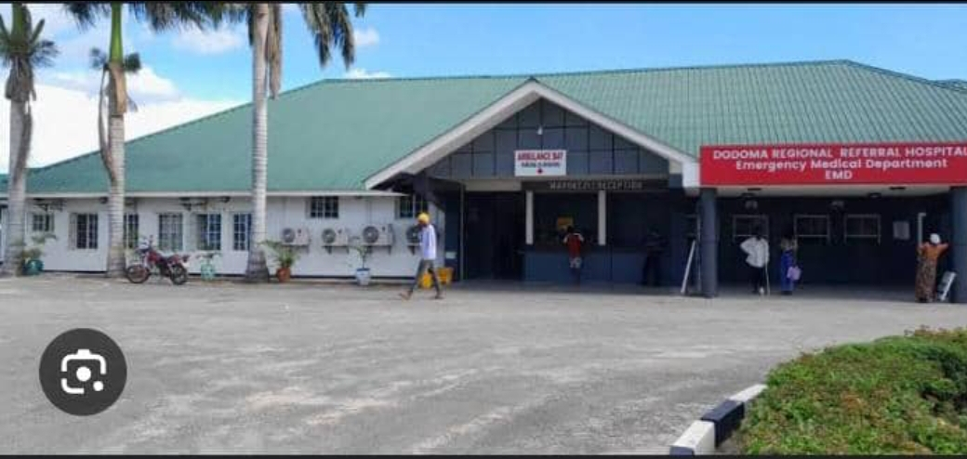
Figure 1.A photo showing Dodoma regional referral hospital .

Activities Performed

First week, July 22, 2024–July 27, 2024: I started with an orientation that covered a number of hospital areas, such as medical record, Bima , emergency ,Care Treatment Center(CTC) , and Maternity departments. I worked on things like registration of new and continuing patients, giving authorization services for patients going for physiotherapy,optical approval and dental approval using NHIF service portal and taking patient signature after they finish treatment for those who use NHIF insurance. All these activities I practiced in the Bima department.
Week 2 (July 29–August 3, 2024): I switched my attention to the Care Treatment Center (CTC) and learnt how to handle patient transfers, confirm current registrations, and register new patients. In addition I practice arrangement of patient files (manual files) in their shelves ,searching and retrieval of patients manual files for those who came for clinic and measuring their body weight before physician consultation .

Week 3 From August 5 to August 10, 2024: I switched my attention to the medical record department which is the mother of all departments dealing with patient and hospital information it is also called MTUHA department. Here I practiced filling daily bed state and bed occupancy in the DHIS2 of all admitted patients, filling monthly report of dental treatment , registering of death and writing monthly report on death. Also I practiced entering in the DHIS2 the weekly and monthly report of all departments of the hospital and preparing the weekly and monthly report of MTUHA department.

Week 4 (12 August 2024 – 17 August 2024): I moved to the Emergence department, here I practiced registration of new and continuing patients who use cash ,NHIF,CHF and JWTZ sponsors , referred prisoner patients for medical clearance, posting referrals and verification and authorization of NHIF cards.

Week 5 August 19, 2024 to August 24, 2024;I moved to the maternity department I also practiced registration of new and continuing patients who use cash ,NHIF,CHF and JWTZ sponsors while on the ward I attended on registering of pregnant women, verification of their details, report generation, and medical treatment recording. I laced the attendance books; posted referrals; and ensure correctness for all data entered. This week was concentrated on the practical aspect of Patient management and data integrity in the clinical practice.

Week 6: August 27, 2024 to August 31, 2024: I returned to the Bima department where by I worked on things like registration of new and continuing patients, giving authorization services for patients going for physiotherapy,optical approval and dental approval using NHIF service portal and taking patient signature after they finish treatment for those who use NHIF insurance.

Week 7: September 2, 2024 to September 7, 2024: I returned to the Care Treatment Center department where by I handled patient transfers, confirm current registrations, and register new patients. In addition I practice arrangement of patient files (manual files) in their shelves ,searching and retrieval of patients manual files for those who came for clinic and measuring their body weight before physician consultation .
Week 8: September 9, 2024 to September 13, 2024:I shifted to TEHAMA and Bima department where by in TEHAMA I practiced window activation, fixing the hospital systems in departments which have problems and in Bima I practicedregistration of new and continuing patients, giving authorization services for patients going for physiotherapy,optical approval and dental approval using NHIF service portal and taking patient signature after they finish treatment for those who use NHIF insurance.

THE ORGANIZATION PROFILE

2.0 Dodoma Regional Referral Profile
Dodoma Regional referral hospital is located in Central Tanzania within Dodoma city council. Its history goes for back to 1930 when it started officially as a hospital. To be more precise it was established before the second World war, as a health camp which offered health services to causalities of the 1st World War. Dodoma Regional Hospital has bed capacity of 420 and an outpatient department with 35 rooms including specialized clinics. On average 400 outpatients are attended per day in this department. Due to the fact that the ophthalmology ward and isolation wards are not fully occupied, average bed occupancy rate is 67%. The length of Hospital stays ranges between 3 days and about 5214 operations are performed in a year. The number of deliveries is between 35 and 40 per day with care section rate of 23%.

Dodoma Regional Referral Hospital serves as a Referral Centre for District Hospitals of Kondoa, Kogwa, Mpwapwa and Chamwino as well as other neighboring districts of Kiteto (manyara Region), Manyoni (Singinda Region) and Gairo (Morogoro Region). It also serves as a District Hospitals for Bahi District since the district has no hospital of its own. More ever it serves those who come directly from home.

The Hospital is under the regional commissioner’s office and is managed by the Regional Referral Hospital Management team headed by the medical Officer in Charge and coordinated by Administration, clinical services and support services.

2.1 Mission and Vision

Mission

To provide high quality Preventive, Curative, Rehabilitative and Promotive health Care services which are equitable readily available medicines and diagnostics, affordable and delivered by competent staff.

Vision

We aspire to be a Centre of Excellence in provision of Health services of high quality to our clients in Dodoma Regional and the Whole country by 2026.

2.2 Dodoma Regional Referral Hospital Structure

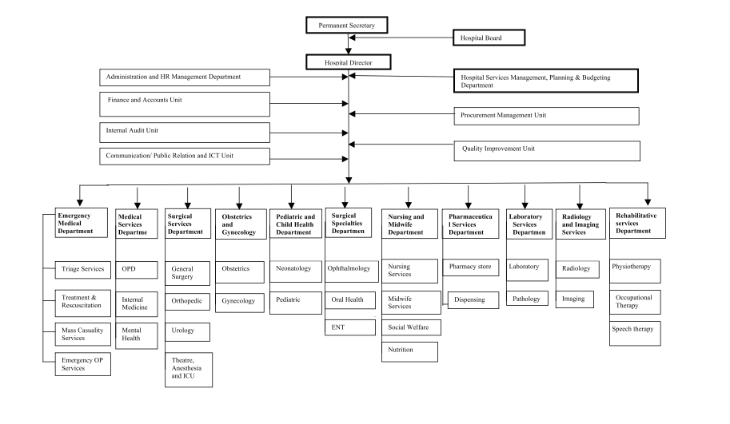

Figure 2. Dodoma regional referral hospital administrative structure

BODY OF REPORT

The body of this report provides a comprehensive overview of the tasks performed and achievements accomplished during the Industrial Practical Training (IPT) period, which lasted from July22th to September13th, 2024. This section is organized into subsections to detail the various activities, projects, and learning experiences. It also covers the new skills and knowledge acquired, along with the implementation of these skills to address specific challenges encountered during the training.

3.1 Tasks Performed and Achievements

3.1.1 Patient Registration

During my fieldwork, I was actively involved in registering new and returning patients across several departments. In the Emergency Medical Department (EMD), I managed patient registrations for both cash payments and those covered by insurance schemes like CHF and NHIF. Also in the Maternity Clinic, I registered pregnant women and newborns, ensuring their data was meticulously entered into the Afya eHMS system. But also, at BIMA OPD, I handled registrations for patients with various insurance cards, providing insight into the administrative processes related to insurance management in outpatient services.

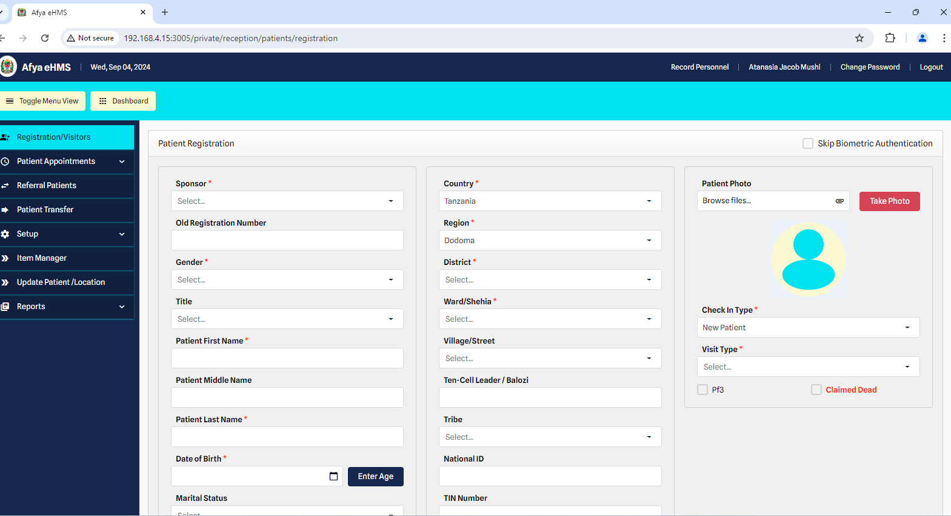

Figure 3. Patient registration layout using Afya Ehms

And In the Care and Treatment Centre (CTC), I registered patients with CTC 2 cards, which was crucial for tracking their attendance and monitoring their progress effectively.

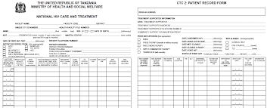

Figure 4. A Picture Showing CTC 2 card

ACHIEVEMENTS:
One of my notable achievements during my fieldwork regarding patient registration was the successful management of patient registrations across these diverse departments, which significantly enhanced the efficiency of patient flow and data accuracy. By handling registrations in the EMD, Maternity Clinic, BIMA OPD, and CTC, I not only ensured accurate record-keeping but also contributed to streamlined operations and better tracking of patient progress.

3.1.2 Data Entry

In the MTUHA department, I was responsible for taking demographic data from Afya eHMS, entering bed occupancy information, and proxy indicators into the and Tanzania’s HMIS (DHIS 2).

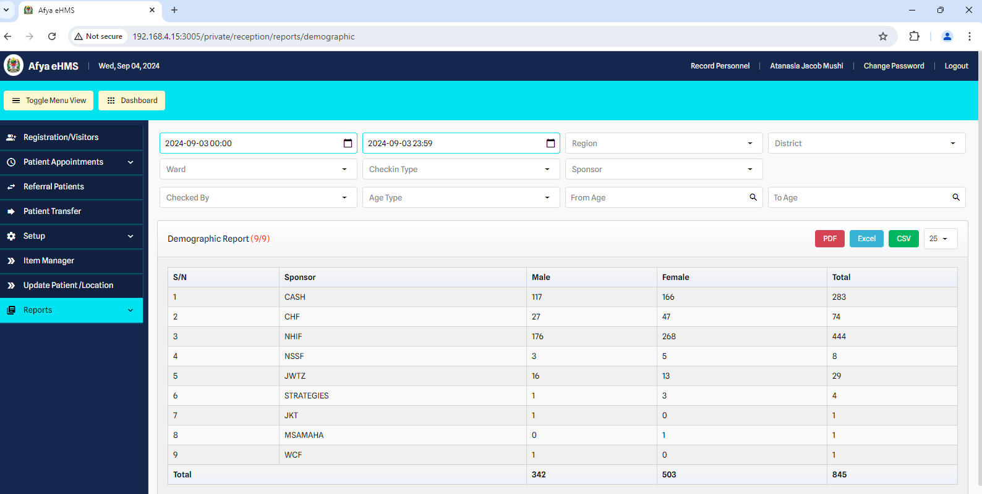
Figure 5. A picture showing demographic reports

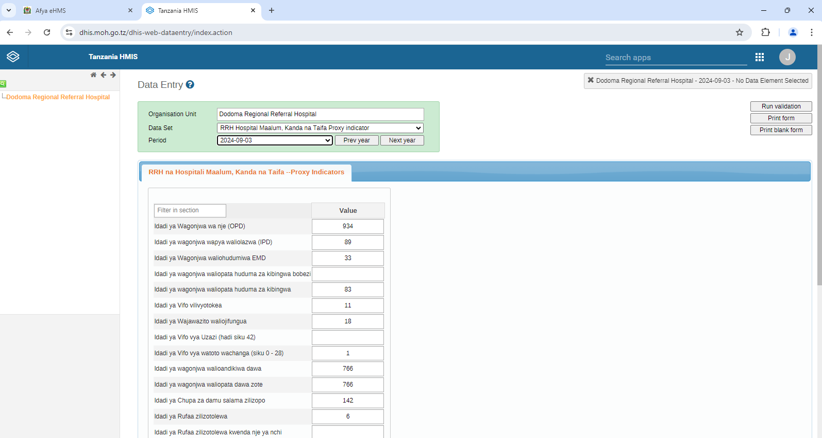
Figure 6. A picture showing data entry for proxy indicators

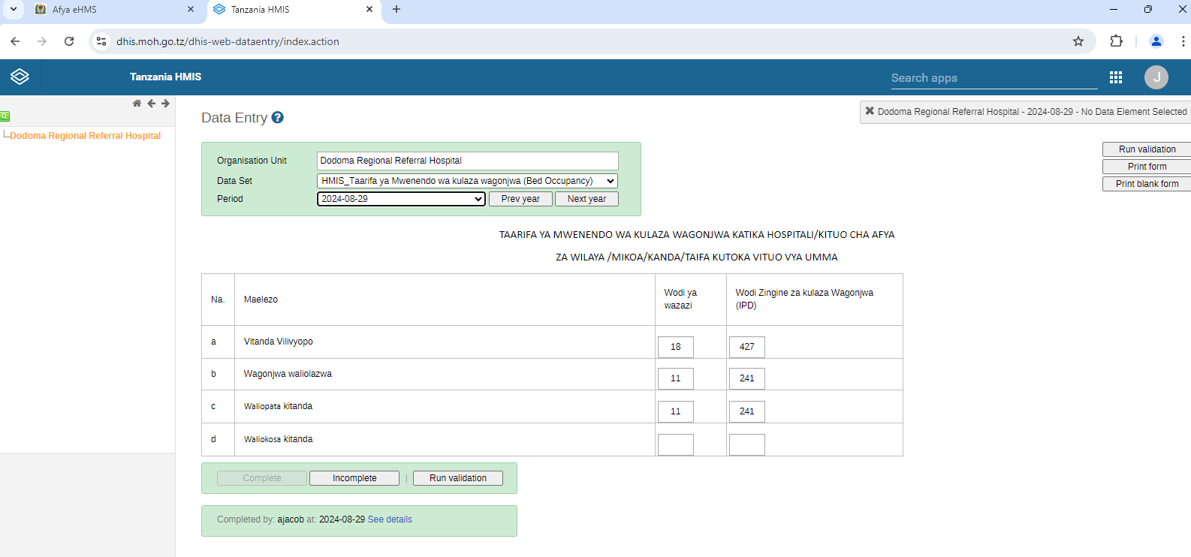
Figure 7. A picture showing Data entry of Bed occupancy

ACHIEVEMENTS
This role enhanced my data management skills and emphasized the importance of accurate data for hospital administration and decision-making.

3.1.3 Preparation and Compilation of Weekly Reports
In MTUHA, I prepared and compiled comprehensive weekly reports for the hospital. This involved aggregating data from various sources and presenting it in a format useful for hospital management.

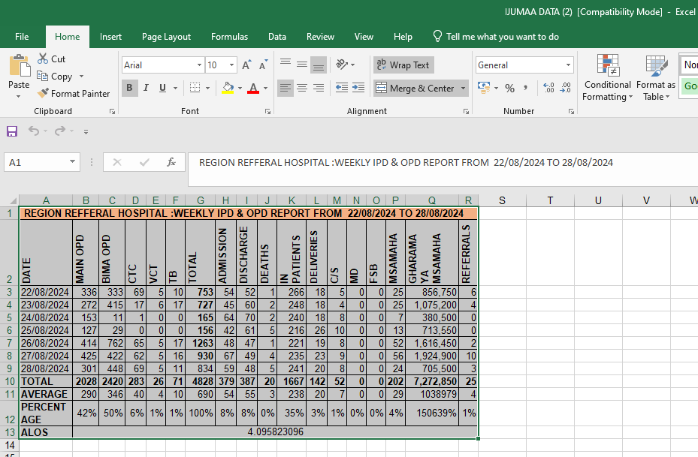
Figure 8. A picture showing weekly reports of DRRH
ACHIEVEMENTS:
This experience honed my report-writing skills and emphasized the importance of clear, accurate reporting in healthcare settings. These activities are crucial for maintaining accurate records and supporting effective healthcare decision-making (Health Information and Quality Authority, 2017; Ministry of Health, Tanzania, 2019).

3.1.4 Documenting Referrals

During my fieldwork, I was responsible for documenting patient referrals to other hospitals using Excel. This task involved recording detailed information about patients who were referred from Dodoma Regional Referral Hospital (DRRH) to external facilities. I meticulously entered data including patient details, reasons for referral, and referral destinations into an Excel spreadsheet.

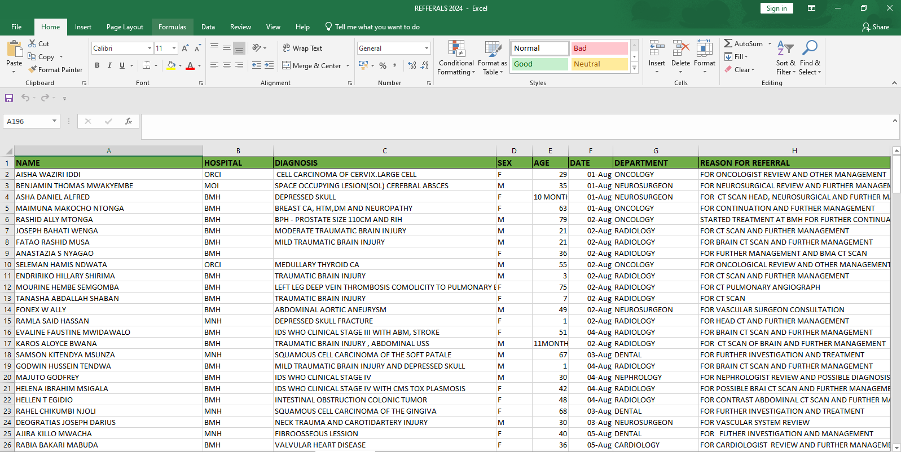

Figure 9. A picture showing referrals details

Achievement:
An important achievement in this task was the development and implementation of a well-organized Excel-based system for documenting referrals. This approach not only streamlined the referral process but also improved data accuracy and accessibility.

3.1.5 Networking and ICT Issues
In the Information and Communication Technology (TEHAMA) Department, I addressed networking issues. This role involved troubleshooting and resolving network problems, which ensured the smooth operation of the hospital’s information systems.
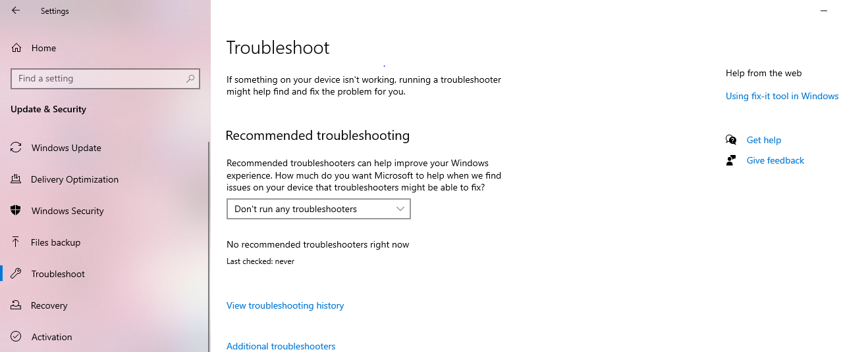
Figure 10. A picture showing troubleshoot issues

ACHIEVEMENTS
This experience enhanced my problem-solving skills and understanding of IT infrastructure in healthcare settings.

3.1.6 Documentation and Filing
At the CTC, I managed patient files by retrieving them for clinic visits and organizing them back into their respective shelves. Effective documentation and filing are essential for maintaining accessible and up-to-date patient records, which supports the continuity of care (Jones, 2020).

The body of the report provides a detailed account of the work performed and the achievements during the Industrial Practical Training (IPT) period. Each section below will focus on specific tasks or projects completed, highlighting new knowledge and skills acquired.

4.0 New Knowledge and Skills Learned

During the IPT, I acquired several new skills and knowledge:

- Data Management: I gained proficiency in using the Afya eHMS and DHIS 2 systems for data entry and management, which improved my ability to handle and analyze healthcare data effectively.
- Patient Registration and Documentation: I learned the intricacies of patient registration, including managing various types of insurance and handling sensitive patient information.
- Networking and IT Troubleshooting: I developed skills in troubleshooting network issues, which are crucial for maintaining the functionality of healthcare information systems.
- Report Writing: I enhanced my report-writing skills by preparing and compiling comprehensive weekly reports, which improved my ability to present data clearly and effectively.
In MTUHA, I prepared and compiled comprehensive weekly reports for the hospital. This involved aggregating data from various sources and presenting it in a format useful for hospital management

CONCLUSION AND RECOMMENDATION
Benefits Derived from the Training

1.Skill Building: The vocational training has allowed me to evolve and hone certain key skills, such as those involving patient registration, billing, data management, and verbal/written communication. These aforementioned skills are very vital in any medical administration position; thus, it better prepared me for future employment challenges.

2.Real-World Application: Through working with actual hospital systems and procedures, one cultivated appreciation for the intricacies associated with medical administration. I did handle patient data, financial transactions, and coordination between departments.

3.Professional Growth: Working among experienced professionals both on the medical team and at the administrative level made for personal and professional growth. The dynamics of a hospital environment, the accuracy and confidentiality that have to be maintained, and communication-all these come into play regarding learning for me.

Weaknesses:

1.Exclusion of Exposure to Specialized Areas:

Details: The trainee had no opportunity to work much with the specialized areas of the medical practice and hospital management in this training. While, therefore, the internship training currently administered some general administrative tasks and basic management of the patients, very minimal exposure to advanced medical procedures, diagnostic techniques, and treatment protocols took place.

Impact: This will only offer the trainee limited exposure; wherein, he or she will not be in a position to comprehend with all aspects of the hospital. Other specializations that were not deeply covered included advanced radiology, surgical

procedures, and in-depth patient care. The incomprehensive nature of some exposures may be a disadvantage for the students seeking varied exposure.

Level and Appropriateness of the Work Performed:

Work Level: The work allocated for the training was appropriate and suitable for an individual's experience level that would be expected from a final-year student. The work encompassed a mix of administrative duties, data management, and patient interaction that can provide good all-round exposure.

Appropriate: The work carried out was relevant and provided practical exposure that is directly applicable to the competencies and knowledge requirements of medical administration. In addition, the training was well-organized in terms of providing an opportunity to apply the theoretical inputs in the real world.

Recommendations

For Future Students:

Preparation: The coming student trainees should be introduced to the systems and procedures at the hospital for ease of learning and adaptation. This will, in the process, provide the necessary speed into the work environment and roles. Different Exposure: The future trainee should ensure exposure to different departments and specialized areas within the hospital for more broad-based understanding of different perspectives on medical administration and care for patients.

Long-term training can be recommended; extending the duration would allow the students more time to engage in different tasks and delve deeper into specific areas of interest. This will create better learning experiences and deeper knowledge about how the hospitals operate.

Specialized Training Modules: Incorporate modules on specialized areas such as advanced radiology, emergency care, and protocols for patient care. This would

add value to the training program by exposing students to a wider array of knowledge and skills.

Recommenda0ons on Hospitals:

Systems Structure Orientation: It is recommended that the students should have more enhanced structured orientation so that the students get familiar with the hospital systems and procedures before starting the work. This will make functioning in the work environment easy.

Mechanism for Feedback: Provide an avenue through which the trainees can give valuable insights into their experiences and what they feel is lacking in the training; this will be useful during continuous improvements of the training program, taking care of anomalies.

REFERENCES

h;ps://www.who.int/publicaKons/Ceez retrieved in 2023.

h;ps://www.cdc.gov/hiv/library/reports/surveillance/DHIS2.

h;ps://dhis2.org/documentaKon/.

Baker, J., & Brown C., 2023 - Eﬃcient Use of Electronic Medical Records; Journal of Health InformaKon Science, 15(3):245-260.

h;p://amanarrh.go.tz/.

APPENDICES
Appendix 1: Arrival note
Appendix 2: Logbook
Appendix 3: Assessment Form

